* Welcome Screen

(welcome,

Press any key to continue)

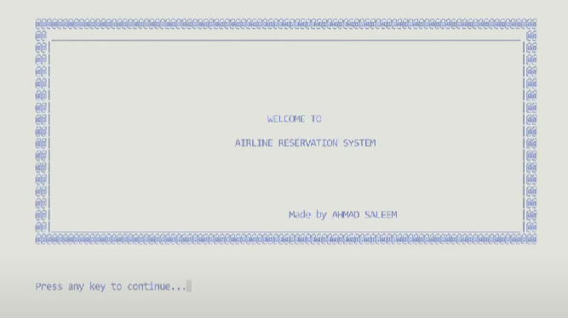

* Main Menu

1. Menu
2. Flight Schedule
3. Instructions
4. Exit

* Menu

1. Reservation
2. Cancel
3. Flight Schedule
4. Check my details
5. Change my Seat
6. Print my ticket
7. Back to Main Menu

* **Reservation (1)**
* Take input
  + Passenger ID
  + Name
  + Age
  + Gender
  + Passport Number
  + Address
  + Contact
  + Number of Luggage
  + Did you fill out your informations correctly[Y/ N]
    - No - (call take input again)
  + You’ve filled out all the entries carefully…
* Show flight schedule & give option to choose
* Select seat Class
  + First class - $1300
  + Business class - $800
  + Prime Economy class - $500
  + Economy - $250
* Select seat type
  + Window seat
  + Normal seat

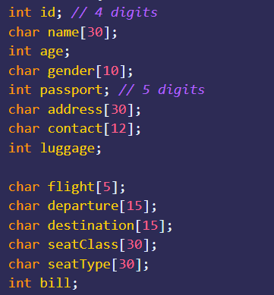

* **Cancel Flight (2)**
* Rewrite post-passenger list file - (don’t write that particular index of array)
* **Flight Schedule(3)**
* Read from the file
* **Check my details(4)**
* Enter Passenger ID — (structure)
* Prints out details

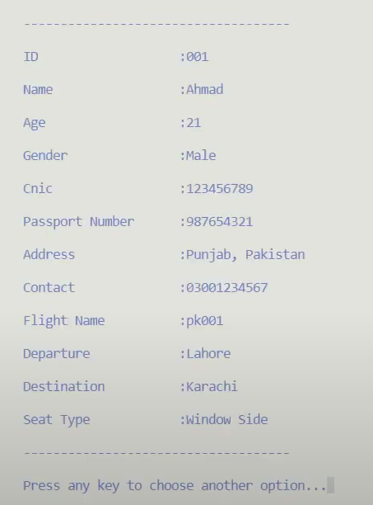

* **Change my Seat(5)**
* Enter Passenger ID
* Select Seat Class
* Select Seat Type
  + Seat has been changed as per your desire
* **Print my ticket(6)**
* Print details (but in different manner)
* **Authority Login(7)**
* Enter preset username
* Enter preset password
* Check if its true
* False enter again
* 1, Menu

1. See Detail of all Passengers
2. Check security
3. List of workers
4. Employ new workers
   1. Select Post

* **Exit (8)**
* Show GoodBye Screen

Rough:

List of files there will be

* Schedule
* Pre-passengers
* Post-passengers
* Authority Login
  + admin
  + 1234
* Welcome Screen
* GoodBye Screen